**Order Status - Vendor FAQs**

**About GSA Advantage Order History & Status**

Each customer who uses GSA Advantage has an order history which is used to manage orders and determine order status. Customers are sent an email anytime the status of an order changes. Your submission of order status using the PO Portal updates customer order history and keeps customers apprised of their order status and reduces phone calls concerning order status.

**What do we mean by “Order Status”? There are (4) Order Status Indicators:**

1. **“In Process” -** When you retrieve orders, your order status is considered “In Process” (you will not see this status). This status is passed to the ordering customer.
2. **“Shipped”** As your fill your orders, you may indicate orders as “Shipped” and may provide the shipped date (i.e. status date), ship method, and the tracking number.
3. You may also indicate orders as **“Backordered” or**
4. **“Cancelled”.**

**How can I sign up to provide order status?**

When a Customer places an order for your schedule product, you will receive a GSA system-generated notice inviting you to register for the PO Portal, if you have not already registered. This email will provide a link to the registration page. Registration for the PO Portal can only be accessed via a GSA generated email notice. You will only need to register for the PO Portal once. However, each order’s status must be entered through the PO Portal.

There are two ways to provide order status through the PO Portal:

1. By Line item/order or
2. Exporting active orders in a range and uploading.

More information can be found on pages 7-9 of the PO Portal Guide [here](https://www.gsaadvantage.gov/images/products/elib/pdf_files/pohp.pdf)

For contractors currently using Electronic Data Interchange (EDI) or cXML for Advantage orders, contractors must provide order status using that method. For EDI instructions, see the GSA EDI Documentation for Vendors section available [here](https://vsc.gsa.gov/EDIUser/gsaadvdocs.cfm)

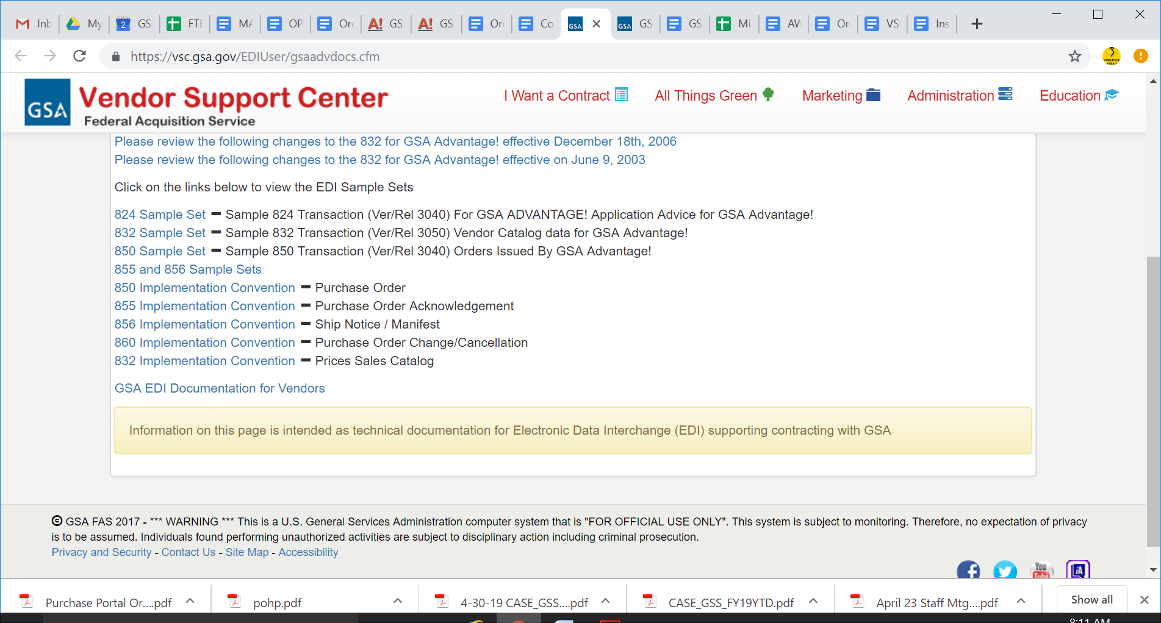

and cXML instructions can be found at the Vendor Support Center (VSC) site: <https://vsc.gsa.gov/>.

**What is Electronic Data Interchange (EDI)?**

EDI is the computer-to-computer exchange of business documents via standard electronic formats. EDI can be used by contractors and ordering agencies for order placement, order changes, and order status. Visit the VSC [website](https://vsc.gsa.gov/) for more information.

**What is the Advantage PO Portal?**

The [PO Portal](https://www.poportal.gsa.gov/poportal/welcome.do) provides a means for GSA contractors to gain immediate access to orders placed through GSA’s Advantage and eBuy systems. The PO Portal also enables contractors to provide ordering agencies with the status of an order. Providing order status information keeps customers informed and reduces inquiries about orders.

**What is the implementation schedule for providing order status?**

**(May 3 - October 31, 2019 for 100% compliance)**

1. Beginning the week of April 30, 2019, GSA’s Multiple Award Schedule (MAS) solicitations will include a requirement that our contract partners provide order status to customers.
2. Contractors should accept the modification within 90 days of receipt.
3. When you receive a GSA system-generated notice inviting you to register for the PO Portal, you should follow the link to the registration page and follow the directions (A notice to register will only be sent to you once an order is received by GSA).
4. For contractors initiating the EDI/XML status transaction process, it can take up to 90 days to become EDI-activated. Therefore, it is best for you to pursue EDI onboarding (**by emailing** [edistat@gsa.gov](mailto:edistat@gsa.gov)**)** as soon as possible after receiving and accepting the Mass Modification.

**I signed the MASS Modification but I am not yet sending EDI/XML status transactions, am I non-compliant?**

No. EDI initiation for order status may take 45-90 days to get a vendor activated and validated appropriately. **As long as you have initiated the EDI/XML status transaction process by emailing** [edistat@gsa.gov](mailto:edistat@gsa.gov) **and signing the Mass Mod., you are responsive.** The timing of the EDI onboarding for status is GSA controlled (once contractors have emailed the EDI team), so we understand that you may not be able to provide order status immediately.