General Services Administration (GSA)

JSON Purchase Order Startup Packet

October 24, 2023

Table of Contents

1. JSON Implementation Process and Instructions 1

2. JSON Vendor Checklist 2

3. JSON Purchase Order Guidelines 3

4. JSON Purchase Order Cancellation Guidelines 5

5. JSON Purchase Order Status Guidelines 6

1. JSON Implementation Process and Instructions

This packet provides the documentation and instructions for Vendors to follow to begin receiving JSON purchase orders from GSA. This packet contains the following documents:

* GSA JSON Vendor Checklist
* GSA JSON Purchase Order Guidelines
* GSA JSON Purchase Order Cancellation Guidelines
* GSA JSON PO Status Guidelines

Please follow the GSA JSON Vendor Checklist to ensure that all required information is transmitted to your GSA point of contact. At a minimum, all mandatory tasks must be completed prior to entering the testing phase. We provide two interface options: HTTPS and SFTP.

For the HTTPS interface, we will post purchase orders and cancellations directly to your server endpoint. You would post status transactions back to our server endpoint.

For the SFTP interface, we would set up a mailbox/account for you and drop purchase orders and cancellations for your pickup. You would drop status transactions back to us for automatic pickup and processing.

The GSA JSON Purchase Order Guidelines document provides an example of a GSA JSON order containing the elements and attributes supported by GSA. Notes about the elements/attributes are provided when needed.

The GSA JSON Purchase Order Cancellation Guidelines document provides an example of the cancellation of an entire GSA order as well as an example of a cancellation of individual line items. GSA does not allow purchase order changes and only allows the cancellation of an entire purchase order or an entire purchase order line item (no partial quantities).

The GSA JSON Status Guidelines document provides an example of shipment(accept) / backorder / reject(cancellation) status transactions for a GSA JSON order containing the elements and attributes supported by GSA.

1. JSON Vendor Checklist

|  |  |  |
| --- | --- | --- |
| **GSA JSON Vendor Checklist** | | |
| Task | Mandatory/Optional | Response |
| What is your Company Name? | Mandatory |  |
| What is your UEI code? | Mandatory |  |
| What is your Contract number(s)? | Mandatory |  |
| Who is your technical point of contact? | Mandatory |  |
| What is the email address of your technical contact? | Mandatory |  |
| What is the phone number of your technical contact? | Mandatory |  |
| Who is your business line point of contact? | Mandatory |  |
| What is the email address of your business line contact? | Mandatory |  |
| What is the phone number of your business line contact? | Mandatory |  |
| Do you want to receive orders via https/post or sftp/mailbox? | Mandatory |  |
| **FOR HTTPS/POST ONLY:** |  |  |
| What is the URL/URI for your website/https endpoint? | Mandatory |  |
| Have you provided GSA with your Certification Authority (CA) certification? | Mandatory |  |
| Do you agree to send a 200 acknowledgement back to GSA upon the successful receipt of a JSON purchase order? | Mandatory | YES  200 Acknowledgement Example:  {  "resp": {  "code": 200,  "text": "OK"  }  } |

1. JSON Purchase Order Guidelines

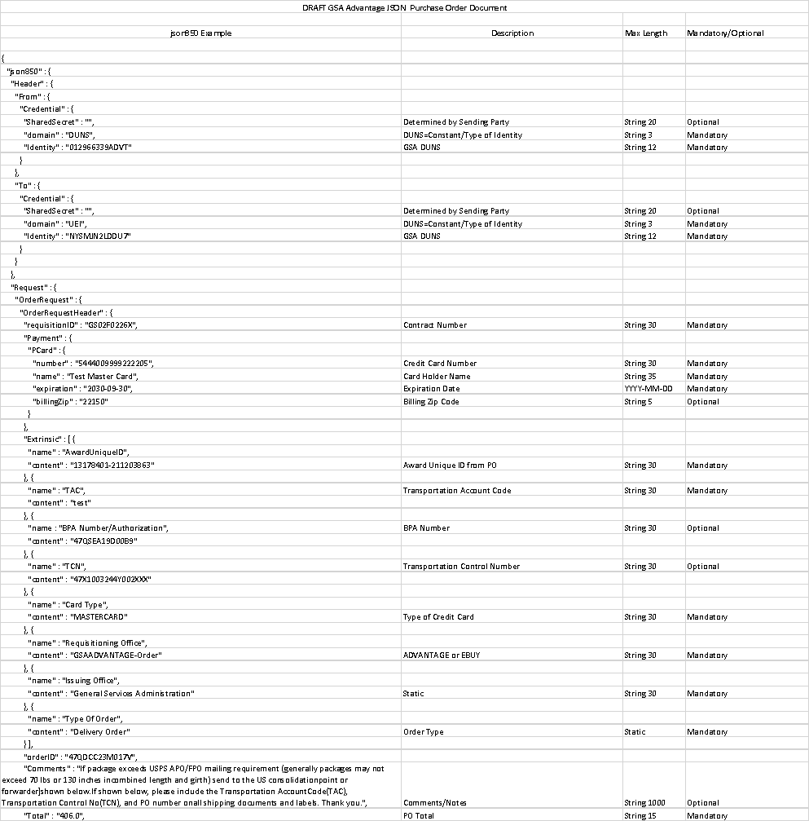

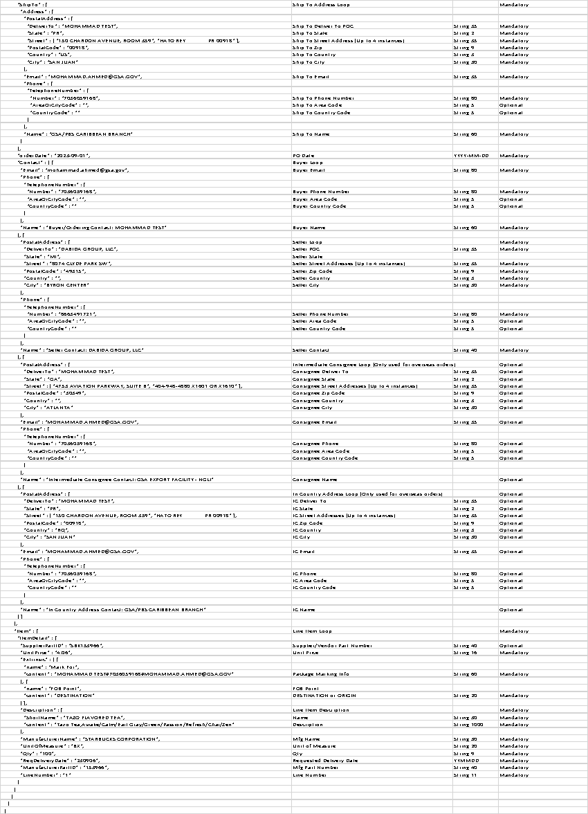

1. JSON Purchase Order Cancellation Guidelines

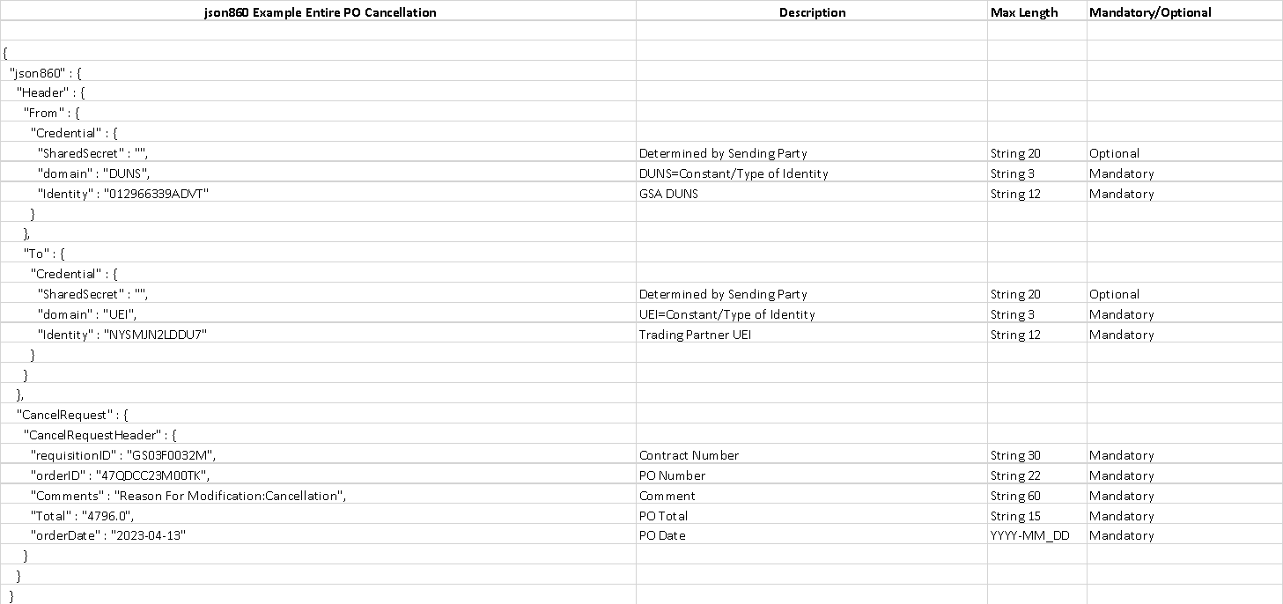

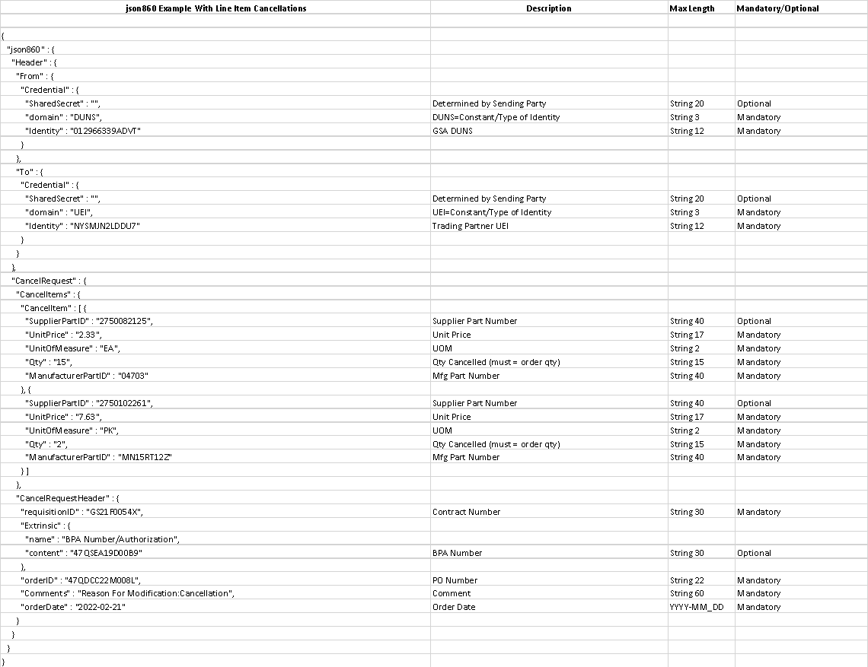

1. JSON Purchase Order Status Guidelines

